Embargo Act of 1807
Make a line graph by charting the export values listed in this chart. Place a dot for each value on the graph, then connect the dots using a ruler. The first values have been charted for you. Color the events on the chart showing the changes between events.

Year | Export Value
1794 | $33 million
1801 | $94 million
1803 | $54 million
1807 | $108 million
1808 | $22 million
1810 | $60 million
1812 | ?

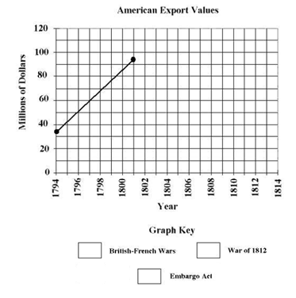

British French Wars 1793-1814
Embargo Act 1807-1809
War of 1812 1812-1814

- Predict on the graph what you believe will happen with trading during the War of 1812 from 1812-1814.

- Do you believe the Embargo Act of 1807 was a good way to protect American traders from European impressment? (Was it worth the cost) Why?

Analyze the following and answer the questions:
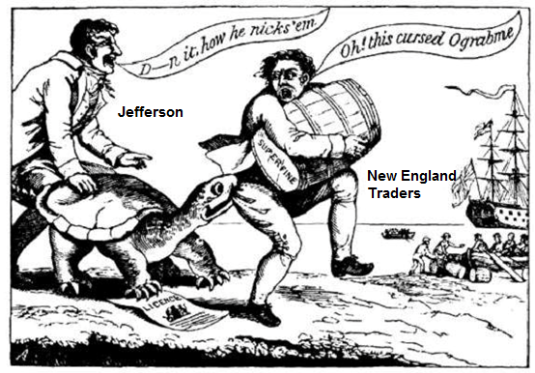
- What point is the political cartoon making? (Hint: Ograbme is Embargo backwards)

- What does the turtle represent in the cartoon? Why do you think they chose a turtle?

- Which region of the country would be most negatively affected by this (and what political party were they primarily)? What would an appropriate reaction to the Embargo would have been by this region?

