John Sevier
George Washington is sometimes known as the “Father of our Country.”
Perhaps John Sevier is the “Father of Tennessee.”
In 1796, the state of Tennessee was formed.
Sevier was elected Tennessee's first governor and would eventually serve in that position for twelve years (1796-1801 and 1803-1809). Sevier also served four terms as a Congressman.
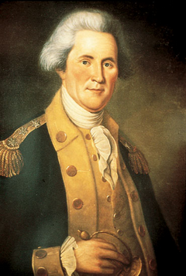

Treaty of Holston
The Treaty of the Holston was a treaty negotiated between the United States government, represented by Governor William Blount of the federal Territory South of the River Ohio (later the state of Tennessee), and the Cherokee Nation, represented by 41 tribal chiefs.
Treaty of the Holston was signed by all parties (some reluctantly among the Cherokee) on July 2, 1791, and was wide ranging in its effects. First, it established a “perpetual peace and friendship” between the Cherokee Nation and the people of the United States. The treaty also required that whites would be allowed unmolested navigation on the Tennessee River
Further, it required the Cherokee to swear allegiance to the United States, ostensibly granting the Cherokee Nation the full protection and aid of the federal government.
Many Cherokee Indians did not agree with the treaty and attack settlements along the Tennessee River.

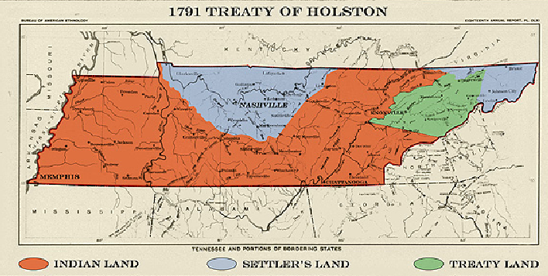

Natchez Trace
the trace was frequented by the Choctaw, Chickasaw, and Natchez tribes who called the region home and traveled upon the trail on hunting and trading expeditions. Later, more explorers would use this “wilderness road,” followed by frontiersmen and pioneers.
Some of the best known travelers of the Natchez Trace were farmers and boatmen from the Ohio River regions of Pennsylvania, Ohio, and Kentucky who floated supplies down to ports in Natchez, Mississippi and New Orleans, Louisiana at the beginning of the 1800's.
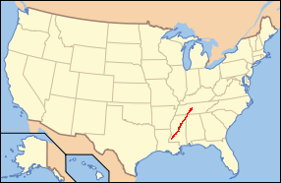

Jackson Purchase
After statehood Tennessee continued to be troubled by conflicting land claims by Native Americans and settlers. Governors John Sevier, Archibald Roane, Willie Blount, and Joseph McMinn looked to the federal government for help, and a series of treaties forged between 1798 and 1819 reduced the land occupied by Native Americans to a small Cherokee claim in the southeast corner of the state.
In 1819 the region opened for settlement, and the general assembly created Hardin County that same year. Speculators John Overton, James Winchester, and Jackson quickly established the town of Memphis. Within six years of its opening, the Jackson Purchase contained sixteen counties.
